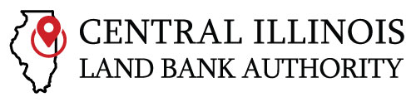 | (217) 655-8190  220 S Broadway, Suite 225  Urbana, IL 61801  www.cilba.org

Central Illinois Land Bank Authority
Board of Directors Meeting
October 16, 2025 from 4:30-6:00
Location: Champaign Public Library
200 W Green St – Room 215
Champaign, IL 61820

AGENDA

- Call to order: roll call

- Welcome/Introductions

- Approval of Agenda

- Approval of Minutes from the August 14, 2025 meeting

- Public Comments

- Executive Director’s Report

- New Business
  - Board Approvals needed:
    - Action Item #1: Approve new accounting contract with Cecillia Rivas, formerly with Clifton Larson Allen

    - Action Item #2: Approve City of Nokomis membership to CILBA

    - Action Item #3: Approve City of Martinsville membership to CILBA

    - Action Item #4: Approve City of Pontiac membership to CILBA

- Discussion Items
  - Brent Denzin, CILBA lawyer, to provide overview on demolition options and pathways to rehab vacant/abandoned properties. The options presented can guide member workplan develoipment.

  - Scott Goldstein, Principal at Teska Associates, to provide overview on technical assistance available through IL Housing Development Authority. Specifically on housing/RE analysis snapshots to capture market opportunities/challenges.

  - Shared Code Enforcement: meet and greet with KC Home Solutions. Company has provided rehabilitation Scope development and construction monitoring for CILBA projects. They are willing to do shared code enforcement on residential/commercial structures.

  - Mike is creating a non-voting “Advisory Board” to help obtain guidance/input from experts in field. Examples members would include:
- David Young, Director of Capacity Building, Housing Action Illinois
- Andrew Greenlee, University of Illinois’ Planning Program
- Jon Kindseth, Village Manager, Park Forest
- Banks, foundations, and other IL orgs engaged in community development

- Adjourn

